RAS Application Suite: Phase I Summary
This document provides a summary of the development activities for Phase I of the RAS development process. The document also outlines any changes to the previous project documentation as well as any new challenges that have arisen.

Milestones
The goal for Phase I, as outlined by the Project Plan document, is to provide a hosted web page that will allow anonymous users to search for automotive recall data. The plan outlined the following tasks for completion:
- Set up the development environment and SCM.
- Set up the web application server.
- Develop a website template for the application design to be used on all pages of the website.
- Add the search form to the RAS homepage and integrate the search form with the USA Search service.
- Create the search results web page that maintained the state of the automotive search from the home page screen and presented the search results from the USA Search REST API.
- Build out the REST API component for interfacing with the USA Search REST service.

Item 1 Status – Development Environment
The team needed to setup the development environment on each workstation before beginning development. Eclipse has been chosen as the IDE of choice for developing the application and has been installed and configured for PHP on each workstation. Additionally, the team decided on using the open source library known as SimpleTest for building automated tests of important features of the site.
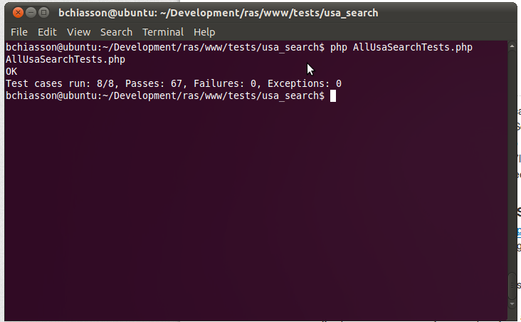
Figure 1-1: Screen shot of latest automated test execution (All tests)
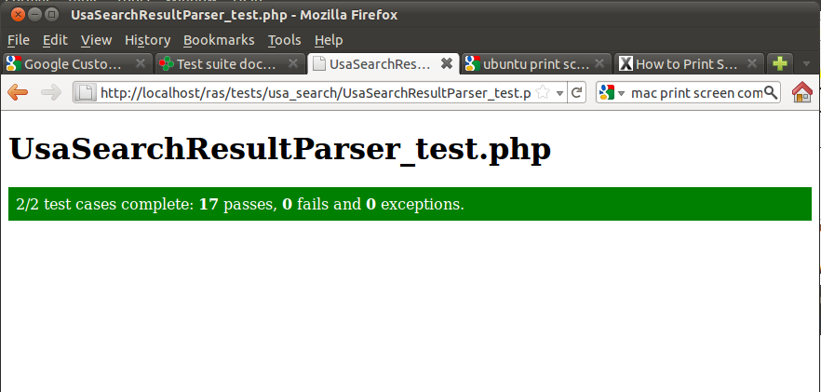
Figure 1-2: UI Screen capture of test run for the USA Search result parser class
For SCM, the team decided to use the centralized, public collaboration features of github. Github allows the team to work in a distributed and disconnected manner. Developers can make local changes to a copy of the code base. When finished, a developer can choose to commit back to the central repository or create a branch for review before changes are integrated into the mainline repository. The only challenge thus far, is that github does not work well with Office documents – it treats them as binary. As a result, it is difficult to work collaboratively on the same document.

Item 2 Status – Web Server Setup
The production web server has been setup on a shared hosting plan with Dreamhost. Currently, the production server is a sub-domain of an existing domain name we own, however, this will change when the site is ready to be live.

Item 3 Status – Website template
The website template was to be the simpler tasks for this phase of the development cycle. Due to the simplicity, it was deemed low risk and the development team decided to leave this task for the end of the development cycle. Unfortunately, due to loss in development resources and other tasks taking longer than anticipated, this task is being pushed to Phase II of development. However, this task will be top priority as we begin Phase II of development.

Item 4 Status – Search Form
The Search Form that allows users to search for automobile recalls has been developed and is currently in a testing phase. The form allows text field input for make, model, and year of the car and submits using the GET action.

Item 5 Status – Search Results
The search results portion has also been developed and is currently in a testing phase. Once a user submits the search form, the form values are converted to a Query and passed on to the USA Search API. Once the results are parsed, they are displayed under the search form.

Item 6 Status – USA Search Rest API
RAS is not responsible for maintaining a centralized database of all recall data. The system relies on third party data stores to provide the recall information that is displayed to the RAS users. For the initial development of the application suite, RAS will be taking advantage of the USASearch API offered by Search.USA.gov. The goal for this task was to build out the classes that are responsible for interfacing with this REST API.

The REST API is exposed via the HTTP protocol through GET requests. Search parameters are provided as query string inputs (e.g. make=Subaru&model=Legacy) and the returned data is sent back using JSON (). To facilitate interaction using HTTP, the development team had two choices within the PHP environment – 1) curl and 2) the PHP HTTP Functions. The team decided to use curl based on the recommendation of a post on the well-respected help site, stackoverflow.com. Deciding to use curl turned out to be the right decision as interfacing with it is simple and results were returned quickly.

Document Changes/Schedule Changes
We have adjusted the Project Plan's deliverables to reflect the move of the website template to the Phase II. The updated chart is displayed below. It should be noted that pushing the website template to Phase II does not impact the schedule.

Deliverable | Date
Project Plan | 6/19
Meeting Notes | 6/20
System & Software Specification | 6/26
Meeting Notes | 6/27
Test Plan & User Guide | 7/3
Meeting Notes | 7/4
Design | 7/10
Meeting Notes | 7/11
Hosted Website (Phase 1)  Provide a hosted webpage with the ability to search for automotive recall data. | 7/17
Meeting Notes | 7/18
Membership Feature (Phase 2)  Complete website template. Enhance the website by adding a membership feature. | 7/24
Meeting Notes | 7/25
Food Recalls (Phase 3)  Enhance the website by adding the ability to search for food recall data. | 7/31
Meeting Notes | 8/1
Consumer Goods Recalls (Phase 4)  Enhance the website by adding the ability to search for consumer goods recall data. | 8/7
Meeting Notes | 8/8
Touch-ups (Phase 5)  Include any bug fixes, touch-ups, and any other enhancements agreed upon. | 8/14
Meeting Notes | 8/15
Final Report | 8/21
Table 1-1: Updated Project Deliverables

